An Order for Holy Eucharist
Autumn 2023
Adapted from Enriching our Worship



Compelled by God's boundless love, we welcome people from all walks of life. We practice a faith that is rooted in Scripture, the traditions of the Episcopal Church, and a deep commitment to a loving community.

ST. BARTHOLOMEW’S EPISCOPAL CHURCH
678 Enos Way, Livermore, CA 94551, (925) 447-3289
Email: saint.barts@att.net
Website: www.saintbartslivermore.com
Opening our doors wider!

The Rev. Andrew D. Lobban, Rector
The Rev. Jennifer Nelson, Deacon

Let our invitation be unmistakable:
All are welcome in this place!

Musical prelude

THE WORD OF GOD

All stand.

Opening Hymn See announcements or hymn board

Celebrant Blessed be the one, holy, and living God.
People Glory to God forever and ever.

The Celebrant prays a Collect for Purity, to which the People respond: Amen.

Song of Praise (sung twice through-please feel free to sing in Spanish or English as preferred)
My Heart Sings Out - #64 Gloria, gloria, gloria
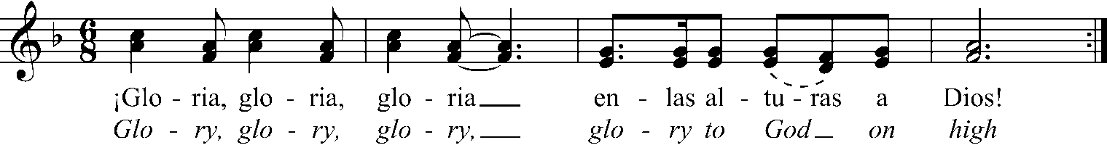
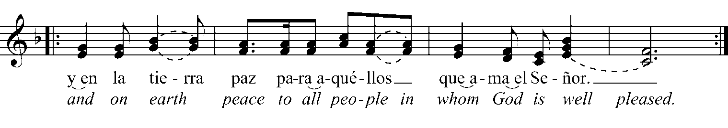
Celebrant May God be with you.
People And also with you.
Celebrant Let us pray.

The Celebrant prays the Collect of the Day, to which the People respond: Amen.

All are seated.

Old Testament or Epistle reading See Scripture insert

After the reading:
Reader The Word of the Lord.
People Thanks be to God.

Psalm See Scripture insert

All stand.

Sequence Hymn See announcements or hymn board

Gospel acclamation and reading
My Heart Sings Out - #22 Heleluyan, Alleluia
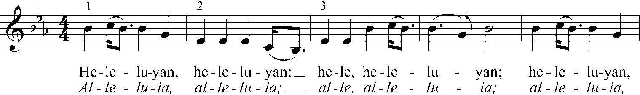
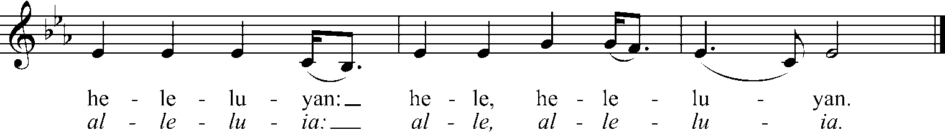

Reader The Holy Gospel of our Savior Jesus Christ according to ______.
People Glory to you, Lord Christ

The Reader proclaims the Gospel.

Reader The Gospel of the Lord.
People Praise to you, Lord Christ.

All are seated.

Sermon

All stand.

Nicene Creed (said in unison)

Celebrant and People
We believe in one God, the Father, the Almighty, maker of heaven and earth,
of all that is, seen and unseen.

We believe in one Lord, Jesus Christ, the only Son of God, eternally begotten of the Father,
God from God, Light from Light, true God from true God, begotten, not made,
of one Being with the Father.
Through him all things were made.
For us and for our salvation he came down from heaven:
by the power of the Holy Spirit he became incarnate from the Virgin Mary,
and was made man.
For our sake he was crucified under Pontius Pilate; he suffered death and was buried.
On the third day he rose again in accordance with the Scriptures;
he ascended into heaven and is seated at the right hand of the Father.
He will come again in glory to judge the living and the dead, and his kingdom will have no end.
We believe in the Holy Spirit, the Lord, the giver of life,
who proceeds from the Father and the Son.
With the Father and the Son he is worshiped and glorified.
He has spoken through the Prophets.
We believe in one holy catholic and apostolic Church.
We acknowledge one baptism for the forgiveness of sins.
We look for the resurrection of the dead, and the life of the world to come. Amen.
Prayers of the People

A leader leads us in prayers for the Universal Church, the nation and all in authority, the welfare of the world, the concerns of the local community, those who suffer or face any kind of trouble, and the departed, as well as in thanksgiving for God’s blessings on our lives. In the silences that follow each bidding, all are welcome to offer up their own prayers aloud or silently.
The Celebrant concludes with a Collect, to which the People respond: Amen.

Confession of Sin
Deacon or Celebrant Let us confess our sins to God.

Ministers and People

God of all mercy, we confess that we have sinned against you, opposing your will in our lives. We have denied your goodness in each other, in ourselves, and in the world you have created. We repent of the evil that enslaves us, the evil we have done, and the evil done on our behalf. Forgive, restore, and strengthen us through our Savior Jesus Christ, that we may abide in your love and serve only your will. Amen.

The Celebrant pronounces absolution, to which the People respond: Amen.

The Passing of Peace
Celebrant The peace of the Lord be always with you.
People And also with you.

The Ministers and People now greet one another in the name of the Lord.

All are seated.

Announcements and blessings of birthdays, anniversaries, and other significant life events

THE HOLY COMMUNION

As the table is set for Holy Communion, an offering is taken to support the ministries of St. Bartholomew’s. Thank you for your generosity!

Offertory music or choir anthem

All stand.

Doxology The Hymnal 1982 #380, v3

Celebrant The Lord be with you.
People And also with you.
Celebrant Lift up your hearts.
People We lift them to the Lord.
Celebrant Let us give thanks to the Lord our God.
People It is right to give our thanks and praise.
All thanks and praise are yours at all times and in all places…And so as the morning stars sing your praises we join the heavenly beings and all creation as we sing with joy:
Sanctus The Hymnal 1982 #S-124

Glory and honor are yours, Creator of all…We acclaim you, O Christ:

Celebrant and People
Dying, you destroyed our death. Rising, you restored our life. Christ Jesus, come in glory!

Send your Holy Spirit upon us…We worship you our God and Creator in voices of unending praise.

Celebrant and People
Blessed are you now and forever. AMEN.

And now, as our Savior Christ has taught us, we are bold to say:

Celebrant and People
Our Father, who art in heaven, hallowed be thy Name, thy kingdom come, thy will be done, on earth as it is in heaven. Give us this day our daily bread. And forgive us our trespasses, as we forgive those who trespass against us. And lead us not into temptation, but deliver us from evil. For thine is the kingdom, and the power, and the glory, forever and ever. Amen.
The Celebrant breaks the consecrated Bread.

Celebrant Alleluia! Christ our Passover is sacrificed for us.
People Therefore let us keep the feast. Alleluia!

Distribution of Communion. All who desire to receive Christ are welcome at the Lord’s Table!

Postcommunion Prayer

Celebrant Let us pray.

Celebrant and People
God of abundance, you have fed us with the bread of life and cup of salvation. You have united us with Christ and one another, and you have made us one with all your people in heaven and on earth. Now send us forth in the power of your Spirit, that we may proclaim your redeeming love to the world and continue forever in the risen life of Christ our Savior. Amen.

The Celebrant pronounces a blessing, to which the People respond: Amen.

Closing Hymn See announcements or hymn board

Dismissal

Minister Let us go forth into the world, rejoicing in the power of the Spirit!
People Thanks be to God.

Musical postlude

